**Part B- Compiler Design Lab- Question Bank**

1. Write a C / C++ program to accept a C program and do error detection & correction for the following. **(CO1)**

Check for un-terminated string constant in the input C program. i.e A string constant begins with double quotes and extends for more than one line. Intimate the error line numbers and the corrective actions to user.

q1.c

#include <stdio.h>

#include <string.h>

int main()

{

FILE *fp;

char line[100];

fp = fopen("text1.txt", "r");

if (!fp)

{

printf("File cant be opened\n");

return 0;

}

printf("File opened correctly!\n");

for (int lineno = 1; fgets(line, sizeof(line), fp); lineno++)

{

int found = 0, flag = 0;

for (int i = 0; i < strlen(line); i++)

if (line[i] == '"')

{

flag = !flag;

found = 1;

}

if (found)

{

if (flag)

printf("\n Unterminated string in line %d. String Has to be closed", lineno);

else

printf("\n String usage in line %d is validated!", lineno);

}

}

return 0;

}

Text1.txt

#include<stdio.h>

#include<conio.h>

int s[35]="gh";

void main(){

int a; char

c[10]="msrit",f[]="lk;

strlen("hjkl); a=a+/*b;

}

Output

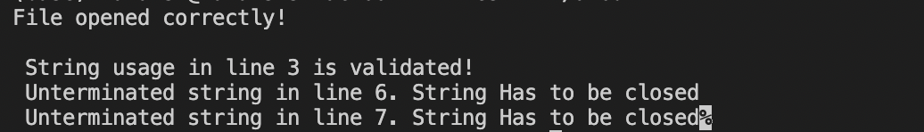

2. Write a C / C++ program to accept a C program and do error detection & correction for the following. **(CO1)**

Check for un- terminated multi line comment statement in your C program.

q2.c

#include <stdio.h>

#include <string.h>

int main()

{

FILE *fp;

char line[100];

int isOpen = 0, openlineno;

fp = fopen("text2.txt", "r");

if (!fp)

{

printf("File cant be opened\n");

return 0;

}

printf("File opened correctly!\n");

for (int lineno = 1; fgets(line, sizeof(line), fp); lineno++)

{

if (isOpen)

printf("\n%s", line);

if (strstr(line, "/*") && !isOpen)

{

isOpen = 1;

openlineno = lineno;

printf("\n%s", line);

}

if (strstr(line, "*/") && isOpen)

printf("\nComment is displayed above!\nComment opened in line no %d and closed in line no %d", openlineno, lineno);

}

if (isOpen)

printf("\nUnterminated comment in begin in line no %d. It Has to be closed", openlineno);

return 0;

}

text2.txt

#include<stdio.h>

#include<conio.h>

/*/*dfgdfgddfgdfg*/

int s[35]="gh";

void main(){

int a;

/*

char c[10]="msrit",f[]="lk;

*/

strlen("hjkl);

/*dgdfgdfg*/

a=a+b; /*

fsdgdgds

sdgfsd sdfsdf

}

Output-

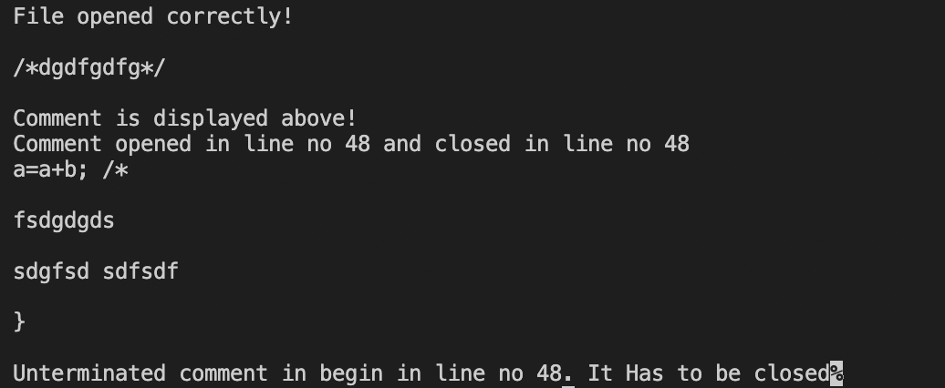

3. Write a Lex program to accept a C program and do error detection & correction for the following. **(CO1)**

Check for un-terminated string constant in the input C program. i.e A string constant begins with double quotes and extends for more than one line. Intimate the error line numbers and the corrective actions to user.

Q3.l

%{

#include <stdio.h>

int c = 1;

%}

%option noyywrap

%%

\n { c++; }

\"[a-zA-Z0-9]*\" {

ECHO;

printf(" Valid String in line number %d\n ", c);

}

\"[a-zA-Z0-9]* {

ECHO;

printf(" InValid String in line number %d\n ",c);

}

. ;

%%

int main()

{

yyin = fopen("text3.txt", "r");

yylex();

fclose(yyin);

return 0;

}

Text3.txt

#include<stdio.h>

#include<conio.h>

#include<string.h>

void main()

{

int a,b,h;

a=a+b;

char d[20]="d",h[67]="yu ;

char c[10]="msrit";

a=a+/b+h;

strlen("msrit");

strlen("msr);

strcpy(c,"Bang

alore);

b=b+*; }

Output-

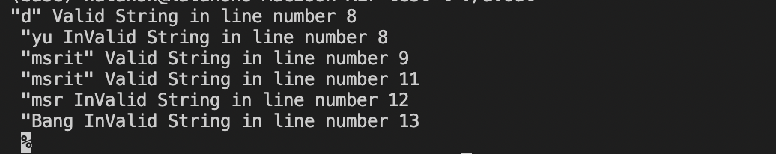

4. Write a Lex program to accept a C program and do error detection & correction for the following.(CO1) Check for valid arithmetic expressions in the input C program. Report the errors in the statements to user.

Q4.l-

%{

#include<stdio.h>

int c=1;

%}

%option noyywrap

operator [-+*/]

identifier [a-zA-Z_][a-zA-Z0-9_]*

number [0-9]+(\.[0-9])?[0-9]*

expression ({identifier}|{number}){operator}({identifier}|{number})

%%

\n { c++; }

^#.+ ;

^(int\s|float\s|char\s).+ ;

(void|int)\smain\(\) ;

{identifier}=({expression}+;) {

printf("Valid expression in line no : %d\t",c);

ECHO;

printf("\n");

}

{identifier}=({number};|{identifier};) {

printf("Valid expression in line no : %d\t",c);

ECHO;

printf("\n");

}

({number}|([0-9]*[a-zA-Z0-9-]+))={expression}+ {

printf("Invalid expression in line no : %d; Lvalue should satisfy the identifier rules\t",c);

ECHO;

printf("\n");

}

{identifier}=; {

printf("Invalid expression in line no : %d; R-value required; Expression is needed at right hand side of assignment operation\t",c);

ECHO;

printf("\n");

}

{operator}{operator}+ {

printf("Invalid expression in line no: %d; More than one operator can't be used in expression consequetively",c);

ECHO;

printf("\n");

}

. ;

%%

int main() {

yyin=fopen("text4.txt","r");

yylex();

fclose(yyin);

return 0;

}

Text4.txt-

#include<stdio.h>

#include<conio.h>

#include<string.h>

int main()

{

int a=1s,b,h;

a=a+b;

a=a+/b+h;

1a=7+j-;

a=;

b=b+*;

}

Output-

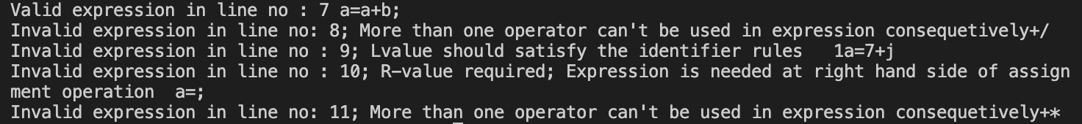

5. Write a Lex program to accept a C program and do the following error detection & correction.(CO1)

Check for the valid usages of numerical constants in the input C program. Intimate the invalid usages to user.

Q5.l

%{

#include<stdio.h>

int c=1;

%}

%option noyywrap

number [0-9]+(\.[0-9])?[0-9]*

invalid [0-9]+(".")[0-9]*((".")[0-9]*)+

%%

\n { c++; }

{number} {

printf("\nValid number in line number %d : ",c);

ECHO;

printf("\n");

}

{number}[a-zA-Z0-9_]+ {

printf("\nInvalid number in line number %d: Number followed with alphabets is invalid",c);

ECHO;

printf("\n");

}

{invalid} {

printf("\nInvalid number in line number %d: Number with more than one decimal point sis invalid",c);

ECHO;

printf("\n");

}

. ;

%%

int main()

{

yyin = fopen("text5.txt","r");

yylex();

fclose(yyin);

return 0;

}

Text5.txt

#include<stdio.h>

#include<conio.h>

#include<string.h>

void main()

{ int a=56;

a=1b; a=a+5h;

a=a+4.5+5.

6.6;

}

Output-

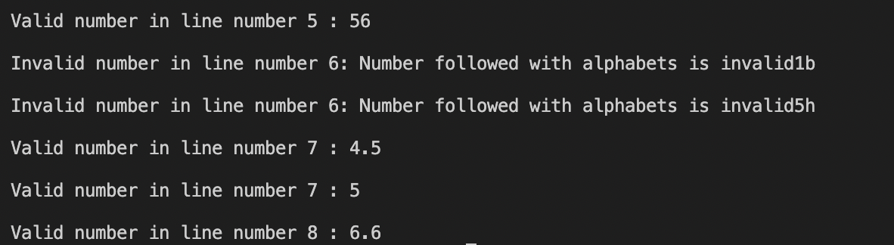

6 Check for valid declarative statements in your program. (CO1) eg: int a,b;

Q6.l

%{

#include<stdio.h>

int c=1;

%}

%option noyywrap

%s DECLARE

identifier [a-zA-Z_][a-zA-Z0-9_]*

number [0-9]+(\.[0-9])?[0-9]*

string \"[a-zA-Z0-9]+\"

%%

\n {c++;}

"int "|"float " {BEGIN DECLARE;ECHO;}

<DECLARE>{identifier}(={number})?, {ECHO;}

<DECLARE>{identifier}(={number})?; {

BEGIN 0;

ECHO;

printf("\nValid declaration\n");

}

<DECLARE>{identifier}("="{string}) {

printf("\n Invalid variable declaration in line no %d; string can't be assigned to integer or float variable:",c);

ECHO;

printf("\n");

}

<DECLARE>[,]+ {

printf("\n Invalid usage of more than one comma in declaration in line no %d",c);

BEGIN DECLARE;

ECHO;

printf("\n");

}

. ;

%%

int main()

{

yyin = fopen("text6.txt","r");

yylex();

fclose(yyin);

return 0;

}

Text6.txt

#include<stdio.h>

#include<conio.h>

#include<string.h>

void main() {

int a=9,b=78;

int a;

int g="78",,;

int a=9 b=0

float c=5.6h=5;

sa=5; a=a+b;

printf("\n");

}

Output-

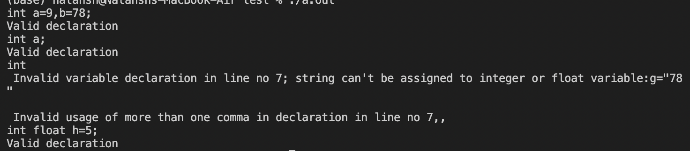

7. Write a Lex program to accept a C program and do the following error detection & correction.(CO1)

Check for the valid if statement in the input C program. Report the errors to users.

Q7.l

%{

#include<stdio.h>

int c=1, bc=0, fc=0;

%}

%option noyywrap

%s IF B1 B2

%%

\n { c++; }

"if" {

BEGIN IF;

ECHO;

}

<IF>\s {ECHO;}

<IF>\( {

BEGIN B1;

bc++;

ECHO;

}

<B1>\( {

bc++;

ECHO;

}

<B1>\) {

bc--;

ECHO;

}

<B1>\{ {

ECHO;

if(bc==0)

{

BEGIN B2;

fc++;

}

else{

printf("\nInvalid if statement, not all closed\n");

BEGIN 0;

bc=0;

fc=0;

}

}

<B1>. {ECHO;}

<B2>\} {

ECHO;

fc--;

if(fc==0){

printf("\nValid\n");

BEGIN 0;

}

}

<B2>\{ {

ECHO;

fc++;

}

<B2>. {ECHO;}

. ;

%%

int main() {

yyin=fopen("text7.txt","r");

yylex();

fclose(yyin);

return 0;

}

Text7.txt

#include<stdio.h>

#include<conio.h>

#include<string.h>

void main() {

int a,b=78;

if((a<5&&j<9) {

a=a+h; g=6+7;

a=a+b;

printf("\n");

}

if

(a<n)

{ h=j+k;

}

if(a<n))

{ g=h+k;

}

}

Output

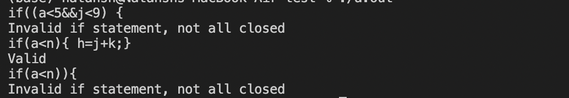

8. Check for un- terminated multi line comment statement in your C program.(CO1)

Q8.l

%{

#include<stdio.h>

int c=1, flag=0;

%}

%option noyywrap

%s COMMENT

%%

\n {c++;}

"/*" {

BEGIN COMMENT;

printf("Comment begins in line no : %d.....\n", c);

ECHO;

flag=1;

}

<COMMENT>"*/" {

BEGIN 0;

ECHO;

flag=0;

printf("\nComment ends in line no : %d.....\n\n", c);

}

<COMMENT>. {ECHO;}

. ;

%%

int main()

{

yyin=fopen("text8.txt","r");

yylex();

fclose(yyin);

if(flag)

printf("\nComment is not closed till the end of file!");

return 0;

}

Text8.txt-

#include<stdio.h>

#include<conio.h>

#include<string.h>

/*dfddf*/ void

main()

{

/*vbhfghfgh

dfhfgh

fghgfhfg

fghfh */ int

a,b=78;

if((a<5&&j

<9) { a=a+h;

g=6+7;

a=a+b;

printf("\n

"); } /*

if(a<n) {

h=j+k; }

if(a<n))

{ g=h+k;

}

}

Output-

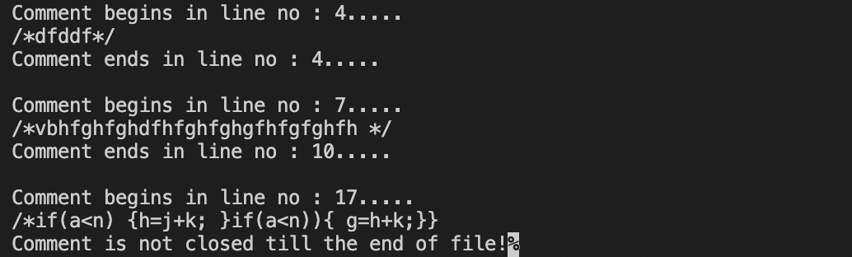

9. Write Yacc program to accept a statement and do the following error detection.(CO2)

a) Check for valid arithmetic expressions in the input C statement. Evaluate the arithmetic expression.

Q9.l

%{

#include "y.tab.h"

#include<stdio.h>

#include<ctype.h>

extern int yylval; int val;

%}

%%

[a-zA-Z][a-zA-Z0-9]* {

printf("\n enter the value of variable %s:",yytext);

scanf("%d",&val);

yylval=val;

return id;

}

[0-9]+[.]?[0-9]* {

yylval=atoi(yytext);

return num;

}

[\t] ;

\n {return 0;}

. {return yytext[0];}

%%

int yywrap()

{ return 1;

}